The US government wants to understand the net inflow and outflow of cash from the country every year. The US trade in goods and services is summarised in terms of Balance of Payments. The Balance of Payments is the difference between Exports and Imports and signifies if there was a Net outflow of cash from the US or a net inflow. This data has been provided from the US Census Bureau, Economic Indicator Division.

* This data is available for Goods and Services from the year 1960 to 2015.
* All Values are in Millions of Dollars

Questions:-

1. Is the Balance of Payments of Goods and Services correlated?
2. Is the correlation real or coincidence?

/*D- understand the correlation between Balance of Payments of Goods and Services */

/* IMPORT DATA*/

**PROC** **IMPORT** DATAFILE='/saswork/SAS_work7F170001C26A_odaws01-prod-sg/#LN00010'

DBMS=CSV

OUT=WORK.BOP;

GETNAMES=YES; **RUN** ;

/* CHECK THE DIMENSIONS OF DATA*/

**PROC** **CONTENTS** DATA=WORK.BOP; **RUN** ;

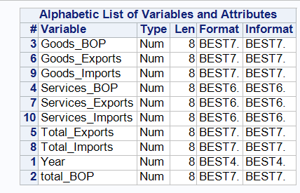

/* Conclusion: - all are numeric*/

/* CHECK DESCRIPTIVE STATS*/

**PROC** **MEANS** DATA=WORK.BOP; **RUN** ;

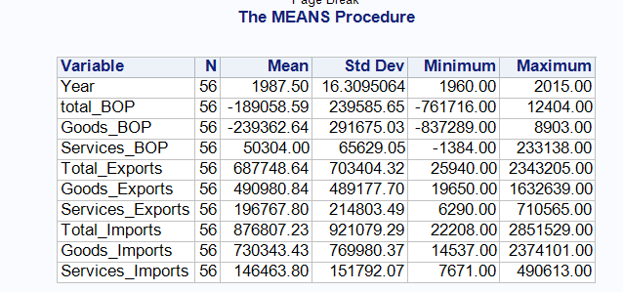

/* Conclusion :- No null or na values */

/* Check Outliers */

**PROC** **UNIVARIATE** DATA=WORK.BOP;

VAR Total_Exports Total_Imports total_BOP;

**RUN** ;

/* limits for outliers

Lower limit = Q1 -(1.5*(Q3-Q1))

Upper limit = Q3 + (1.5*(Q3-Q1))*/

**DATA** WORK.BOP3;

SET WORK.BOP ;

WHERE Total_Exports BETWEEN **2373485** AND -**1254379**

AND Total_Imports BETWEEN **3399729.5** AND -**1872218.5**; **RUN** ;

**PROC** **CONTENTS** DATA=WORK.BOP3; **RUN** ;

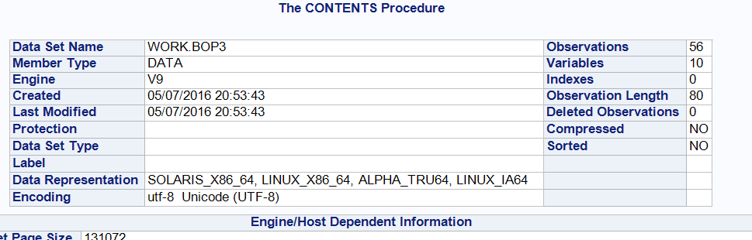

# A- Analyse the data by running correlation between Services and Good BOP

/* A - CORRELAATION */

**PROC** **CORR** DATA=WORK.BOP3;

VAR Total_Exports Total_Imports; **run** ;

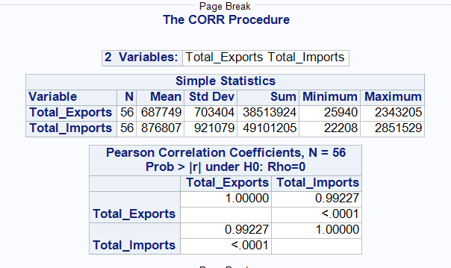

# Conclusion - The correlation coefficient is .99 and the p value is <=.05. Thus we can conclude that the correlation is real and should be accepted

**Task for you: - Please run the correlation for**

1. **Goods_Exports vs Services_Exports**
2. **Goods_Imports vs Services_Imports**

**What is your conclusion?**